Intelligent DNA Chips: Logical Operation of Gene Expression Profiles on DNA Computers
Yasubumi Sakakibara, Akira Suyama
1. Department of Information Sciences, Tokyo Denki University, Hatoyama, Hiki-gun, Saitama 350-0394, Japan
2. Institute of Physics and Department of Life Sciences, Graduate Schol of Arts and Sciences, University of Tokyo, 3-8-1 Komaba, Merguro, Tokyo 153-8902, Japan
Introduction
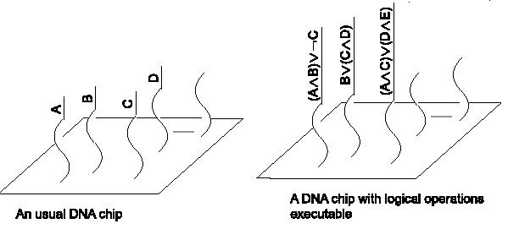
How to Evaluate Boolean Formulae on DNA Strands
There are n Boolean variables (or attributes) and we denote the set of such variables as X_{n}={x₁, x ₂, …, x _{n}}. A truth-value assignment a=(b₁, b ₂, …, b _{n}) is a mapping from X_{n} to the set {0, 1} or a binary string of length n where b_{i} belong to {0, 1} for 1≦ i ≦ n
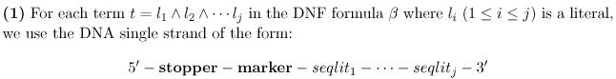
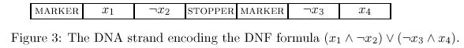
Truth-value Assignment
Let a = (b₁, b₂, …, b_{n} ) be the truth-value assignment. For each b_{i} (1≦ i ≦ n),
if b_{i} = 0 then put the Watson-Crick Complement x_{i} of the DNA substrand encoding x_{i} into the test tube T, and if b_{i} = 1 then put the complement ┐x_{i} of ┐x_{i} into T.
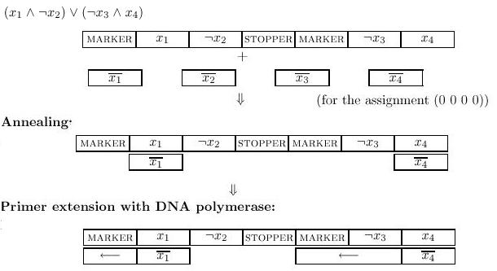
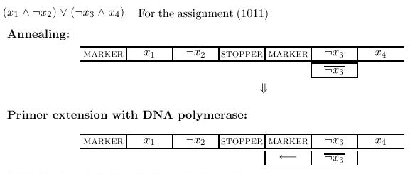
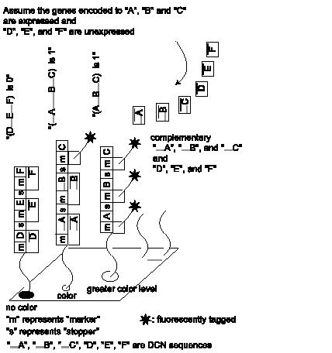

Created by Chie-Yau Hsu
Date: November 20, 2002

